Auto FS

AUTOFS:
- Automount uses the service to automatically mount filesystems when they are accessed and unmount them after a period of inactivity .

In Server Side:
Ensure NFS server is set up and a share is available
#vi /etc/exports

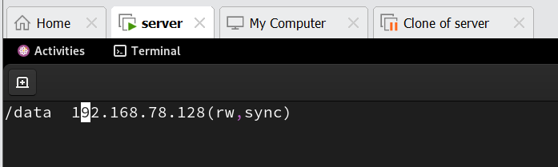

In the client side:
Install autofs package:
#yum install autofs
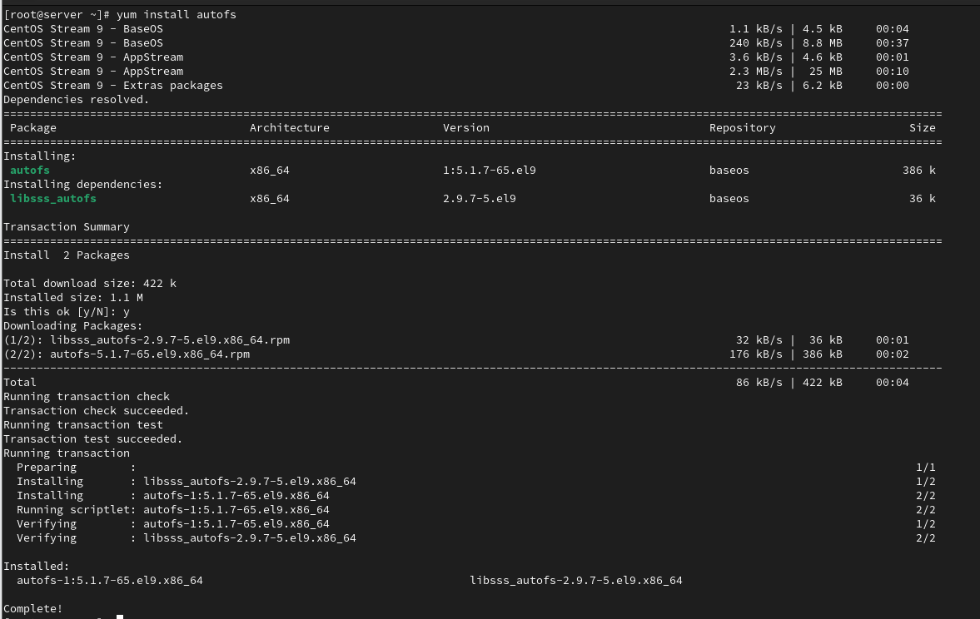

Create directory:
#mkdir samplenfs

Edit the config file and add:
#vi /etc/auto.master
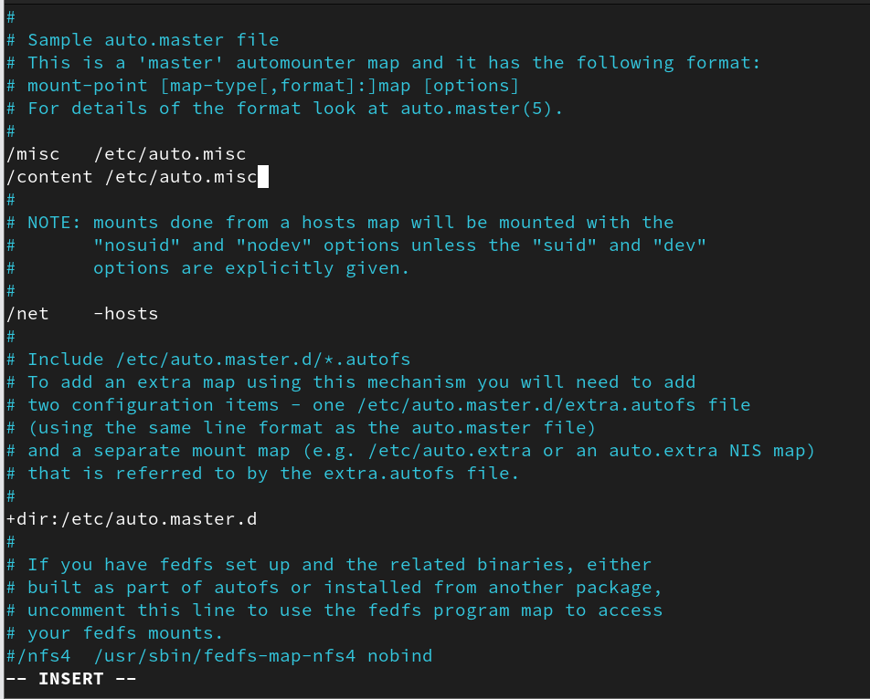

Create /etc/auto.misc
#vi /etc/auto.misc
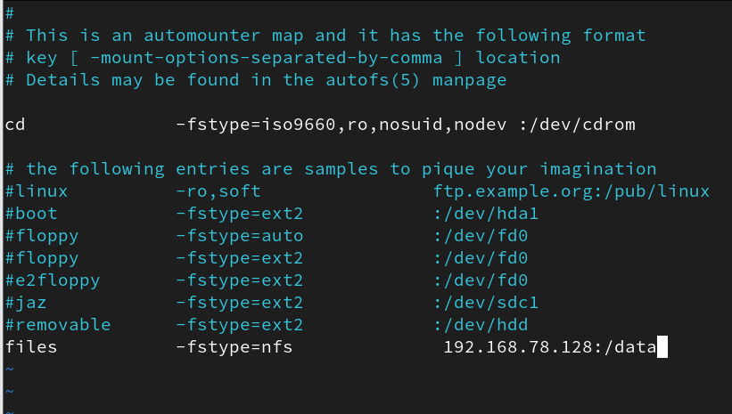

Restart autofs:
#sudo systemctl restart autofs
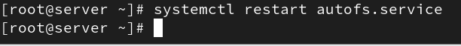

#cd content

To check the shared dir has mounted in the client’s dir:
#df –Th:

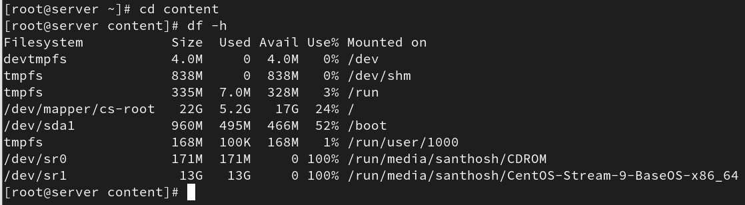

Access the directory to see if it auto mounts:

#cd /content/
#ls
